Study of Automobile Sales with RFM analysis,
PCA and Clustering

Problem statement:
The project aims to analyse automobile sales data to understand the driving factors behind successful sales in the industry. By leveraging RFM (Recency, Frequency, Monetary) analysis, PCA (Principal Component Analysis), and clustering techniques, we seek to uncover patterns and insights that can inform decision-making in inventory management and sales strategies.
Understanding customer preferences and purchase behaviours is crucial in the competitive automotive market. By delving into historical sales data, we aim to predict what influences customer choices, optimize inventory management, and identify key factors contributing to successful sales deals.
Classification or clustering models are ideal for this problem because they allow us to categorize customers based on their buying patterns and preferences. By segmenting customers into groups, we can tailor marketing strategies and sales approaches to specific customer segments, ultimately improving overall sales performance and customer satisfaction.
In essence, this project is about using data-driven insights to enhance decision-making processes in the automobile sales domain, with the goal of optimizing sales strategies and improving business efficiency.

Data:
The dataset "Automobile Sales data" was sourced from Kaggle datasets https://www.kaggle.com/datasets/ddosad/auto-sales-data. It was collected to provide a comprehensive overview of transactions within the automotive sales domain, aiming to understand customer behaviours, preferences, and sales trends. This dataset comprises 2747 rows and 20 columns, with a modest size of 439kB, offering a rich source of information for analytical exploration. One limitation of the data is that it may not represent a global or nationwide perspective, as it could be limited to specific regions, cities, or dealerships. Additionally, there might be missing or incomplete data entries that could affect the analysis.

The dataset includes various types of variables, including numerical and categorical data. Key variables tracked include "ORDERNUMBER" (unique identifier for each order), "QUANTITYORDERED" (quantity of items per order), "PRICEEACH" (individual price of items), "SALES" (total sales amount per order), "ORDERDATE" (date of order placement), "DAYS_SINCE_LASTORDER" (time elapsed since the customer's previous order), "STATUS" (current order status), "PRODUCTLINE" (categorization of product lines), "MSRP" (manufacturer's suggested retail prices), "PRODUCTCODE" (unique product codes), "CUSTOMERNAME" (customer information), "DEALSIZE" (scale of each deal). In terms of relative proportions for classification problems, it would be necessary to examine the distribution of classes within the "DEALSIZE" category (Small, Medium, Large) to understand the balance of deal sizes in the dataset.

One interesting variable is "DAYS_SINCE_LASTORDER," which could provide insights into customer retention and purchasing frequency. Plotting a histogram of this variable could reveal patterns in customer behavior, such as whether there are regular intervals between purchases or if there are significant gaps indicating churn. Understanding these patterns could inform strategies for customer engagement and retention. Additionally, analyzing the distribution of "SALES" could highlight outliers or trends in deal sizes, guiding pricing strategies or sales promotions.

Data Preparation:
Handling Missing Values: Initially, the dataset was checked for missing values using the isnull().sum() function. The "Gender" column had missing values, which were filled with the mode (most frequent value) of the column to maintain data integrity. Rows with missing values were subsequently dropped using df.dropna().
Variable Selection: The "ORDERNUMBER" column, deemed irrelevant for exploratory data analysis (EDA), was dropped from the dataset.
Exploratory Data Analysis (EDA): Exploratory data analysis was conducted to gain insights into the distribution and characteristics of numeric and categorical variables. For numeric variables, histograms and boxplots were created to visualize the distribution and identify outliers. For categorical variables, count plots and pie charts were used to display the distribution of categories.
Visualizations: Various visualizations were generated to understand the distribution of key variables such as "STATUS," "Gender," "QUANTITYORDERED," and "SALES." Histograms, boxplots, count plots, and line plots were utilized to visualize the distribution, trends, and relationships within the data.
Feature Engineering: Date-related features such as "ORDERDATE," "quarter," "year," "month," "week," and "day" were extracted from the "ORDERDATE" column to facilitate temporal analysis and identify seasonal patterns.
Resampling: The dataset was resampled by month to analyze the total sales over time, providing insights into sales trends and seasonality.
Correlation Analysis: Correlation analysis was performed to identify relationships between numeric variables. Heatmaps were generated to visualize correlations, aiding in feature selection and identifying potential multicollinearity issues.

The Exploratory Data Analysis (EDA) reveals several key observations regarding the dataset:
Order Characteristics:
The average quantity ordered is around 35 units, with orders ranging from 6 to 97 units, indicating diverse customer needs.
The average price per item is approximately $101.10, with prices varying widely from $26.88 to $252.87, suggesting a diverse product range.
The average sales amount per order is substantial, at approximately $3553.05, with sales figures varying from $482.13 to $14082.80 per order.
There's a considerable gap of around 1757.09 days between consecutive orders on average, with the time elapsed since the last order ranging from 42 to 3562 days.

Frequent Occurrences:
The most frequent order date is 14/11/2018, with 38 occurrences.
"Shipped" is the most common order status, occurring 2541 times.
"Classic Cars" is the most popular product line, appearing 949 times.
"S18_3232" is the most frequently appearing product code, occurring 51 times.
"Euro Shopping Channel" is the most frequent customer name, appearing 259 times.
Madrid is the most common city in the dataset, with 304 occurrences.
The postal code "28034" appears most frequently, with 259 instances.
The dataset includes records from 19 unique countries, with the USA being the most prevalent, represented 928 times.
"Medium" is the most common deal size, occurring 1349 times.
Product Line Analysis:
Classic Cars, Motorcycles, and Vintage Cars have significant order counts across statuses, indicating their popularity among customers.
These product lines also show both cancelled and shipped orders, suggesting fluctuations in demand or fulfilment issues.
There's effective resolution of customer issues or disputes across various product lines, as evidenced by their presence in the resolved status.

Below are some plots that convey information and patterns of the automobile sales dataset:

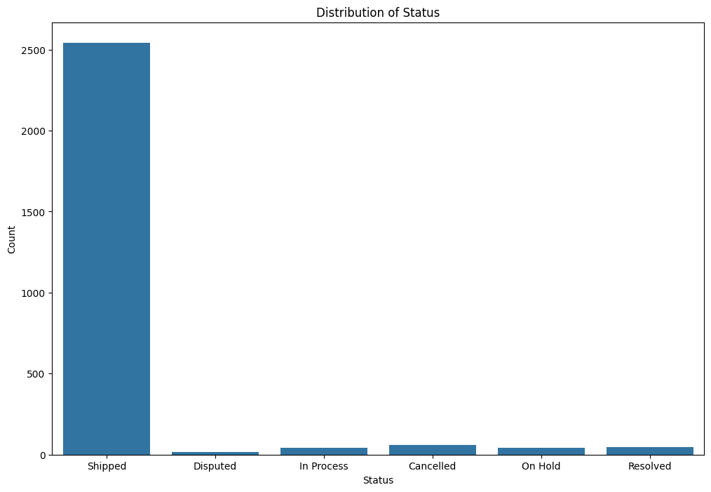
Distribution of States
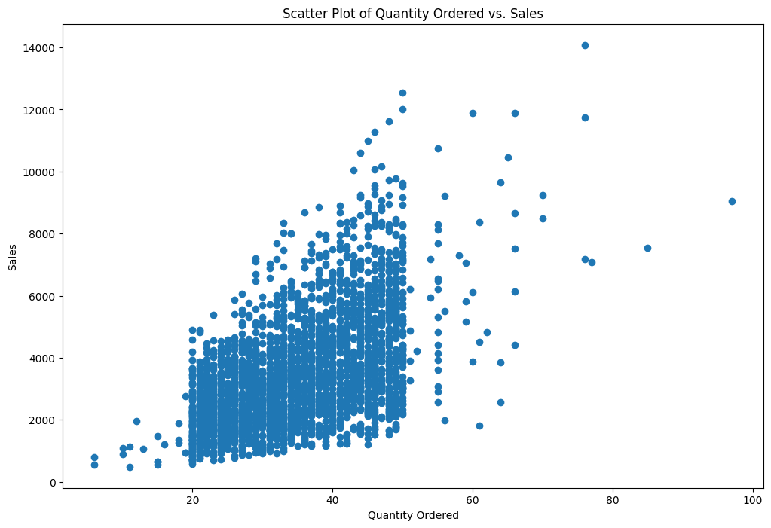

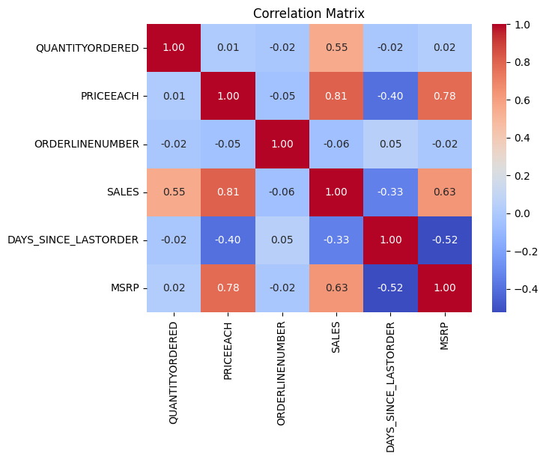
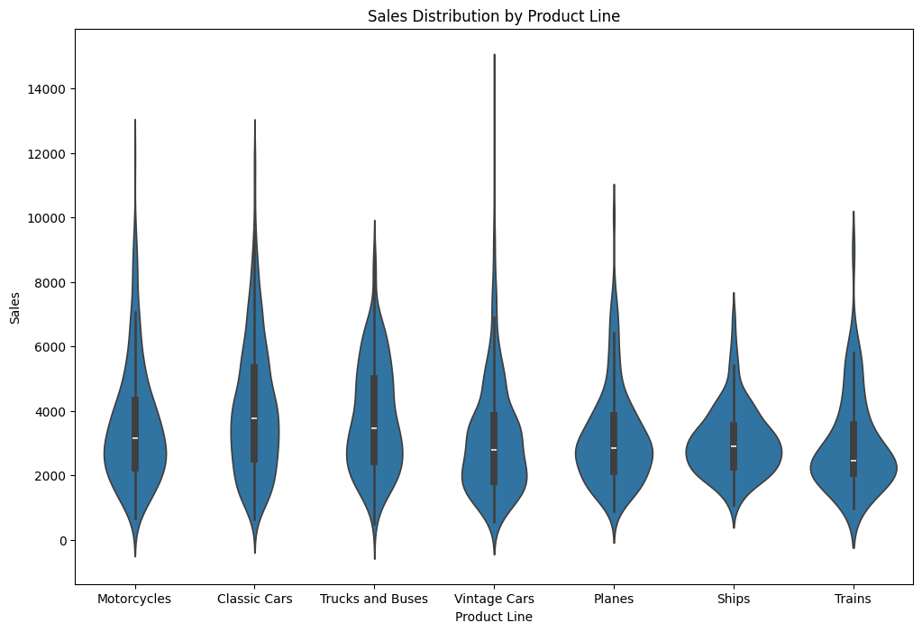

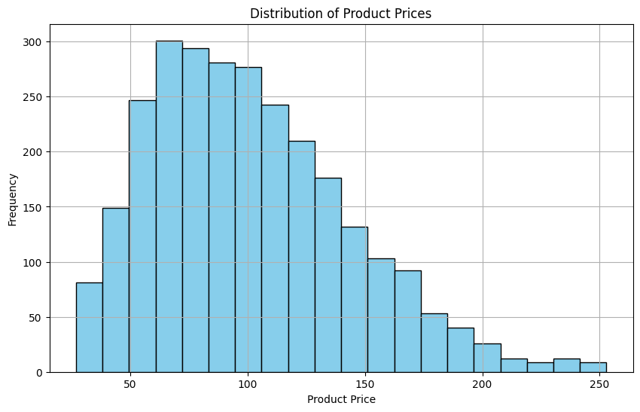
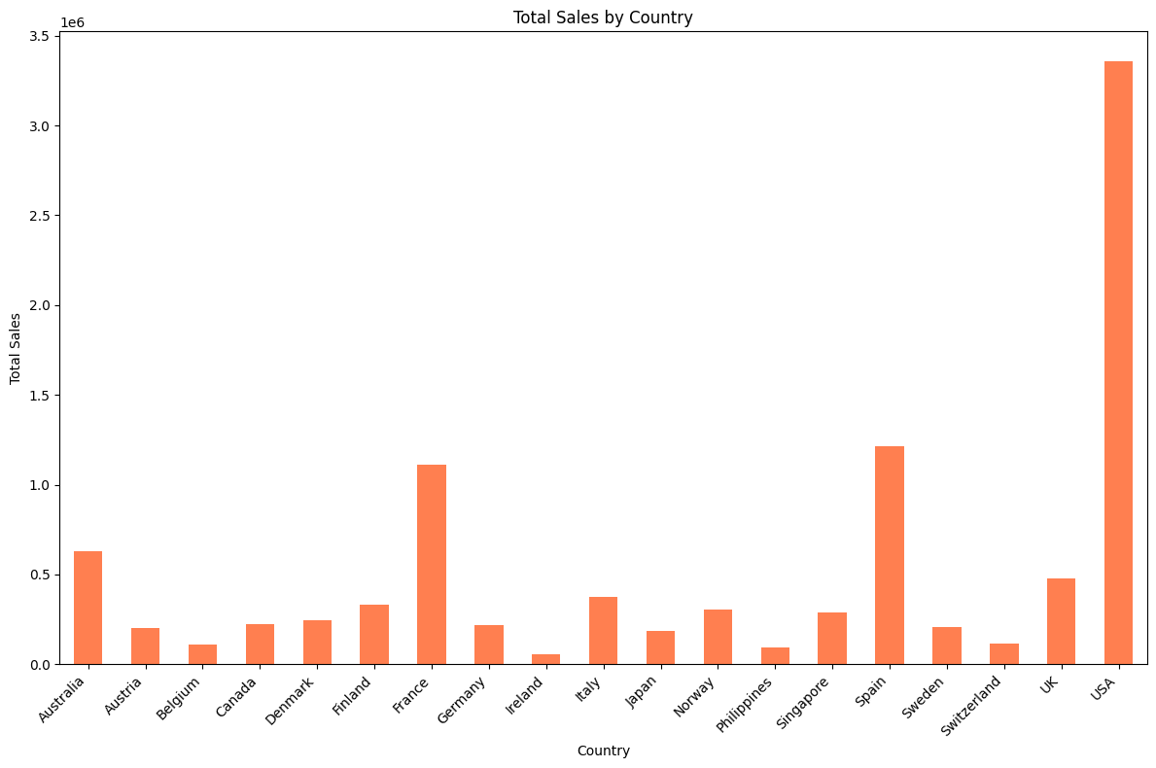

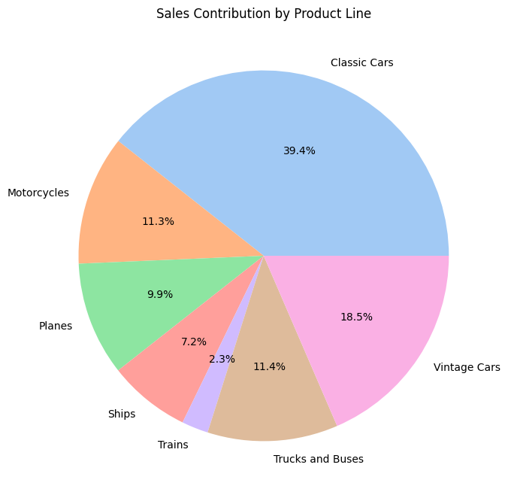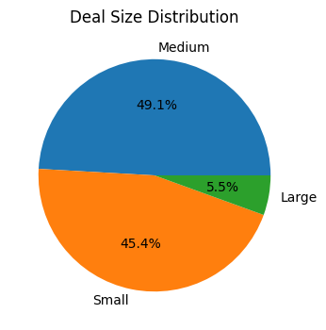
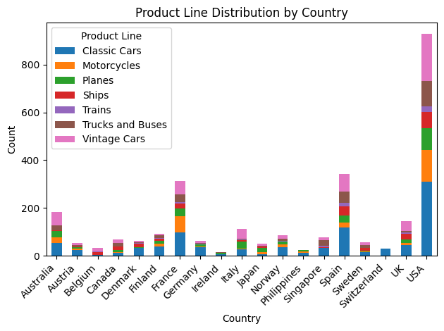
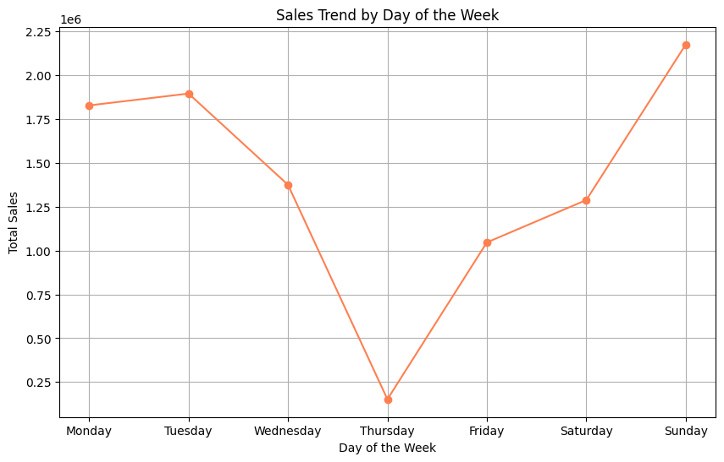
RFM: Recency Frequency, Monetary
RFM, also known as RFM analysis, is a kind of behavioural targeting and customer segmentation that helps companies rank and group their clientele according to the amount, frequency, and recentness of a transaction. To make the best use of their cash, small business owners and marketers can identify their target demographic with the use of RFM marketing.
Analysis of RFM
Three criteria are used in this method to assign scores to customers:
Recency: How recency a customer made a purchase is referred to as their recency. Consumers that just bought something usually in the last few weeks—are more likely to make another buy since they are still thinking about the brand and the goods. Whatever approach you think is best for your company, you can measure recency. Not every few days, weeks, or even months, nevertheless, some businesses may not have clients placing orders. Within 10 years, for instance, a car manufacturer might sell one vehicle to a single person.

Frequency: Frequency is an indicator of a repeat customer's behaviour that tells you how frequently they make purchases. For instance, a lot of customers make repeated purchases on a regular basis over a predetermined period of time. When identifying the people who are most likely to stick with your business after making their first purchase, frequency is crucial.

Monetary value: The amount a consumer spends over a specific time frame is referred to as their monetary value. Since it can provide some insight into the behaviour of consumers, it is always necessary to take into account. For instance, you may discover that although the most valuable clients don't buy as much as the others, when they do, they usually buy the priciest goods.
Businesses may provide objective analysis based on the values of each element and choose which audience to target for the most successful marketing and advertising campaigns. Most businesses utilise a scale ranging from 1 to 5, however we are free to choose any values that you believe are important and useful when assessing clients.
The RFM analysis segments customers into three categories based on their RFM scores: High Value, Medium Value, and Low Value.
The High Value segment consists of recent, frequent, and high-spending customers.
The Medium Value segment comprises customers with moderate RFM scores across recency, frequency, and monetary values.
The Low Value segment includes customers with the lowest RFM scores, indicating they are less recent, less frequent, and low-spending.
Segment profiling reveals average recency, frequency, and monetary values within each segment, providing deeper insights. Pie charts visually represent the distribution of RFM scores within segments, while histograms illustrate the overall distribution across the dataset.
Modelling:
For the clustering task, two main models were built: K-Means clustering and Agglomerative clustering.
K-Means Clustering: K-Means clustering was chosen due to its simplicity, efficiency, and effectiveness in identifying spherical clusters in the data. The Elbow Method was used to determine the optimal number of clusters (k). The model was trained using the scaled dataset (df_scaled) after pre-processing steps like dropping irrelevant columns (ORDERDATE) and scaling numeric features.
Agglomerative Clustering: Agglomerative clustering was selected for comparison with K-Means clustering. Agglomerative is advantageous for its ability to identify arbitrarily shaped clusters and handle noise effectively.
Variables Included in the Model: All numeric variables except "ORDERLINENUMBER" were included in both clustering models. These variables provide insights into customer purchasing behaviour, such as the quantity ordered, price each item, total sales, and MSRP.
Hyperparameter Tuning: Hyperparameters were not explicitly tuned for KMeans clustering in this example. However, the Elbow Method was utilized to select the optimal number of clusters. Due to the simplicity of the problem and dataset, extensive hyperparameter tuning was not performed, but it could be beneficial in more complex scenarios.
PCA (Principal Component Analysis): Additionally, Principal Component Analysis (PCA) was applied to visualize the high-dimensional data in a lower-dimensional space. This technique reduces the dimensionality of the dataset while preserving its variance. The reduced components were then used for visualization purposes, aiding in understanding the distribution of clusters in a three-dimensional space.
Overall, the choice of models and inclusion of relevant variables were guided by the nature of the clustering problem and the need to identify distinct customer segments based on their purchasing behaviour. Comparing the results of KMeans and Agglomerative clustering provides insights into the effectiveness of different clustering algorithms for this specific task.

Evaluation :
Evaluation of the clustering models involved assessing their performance through metrics like silhouette score, Davies-Bouldin index, and visual inspections of clusters. Although hyperparameter tuning, could potentially enhance model performance, it wasn't extensively conducted in this instance. All numeric variables except "ORDERLINENUMBER" were included in the models, with features like quantity ordered, price each item, total sales, and MSRP deemed crucial for capturing customer purchasing behaviour. There exists a trade-off among evaluation metrics; a higher silhouette score indicates better cluster separation, while a lower Davies-Bouldin index suggests better intra-cluster similarity and inter-cluster dissimilarity. Determining the "best" model requires considering specific analysis objectives and tradeoffs between these metrics. Overall, the evaluation integrated quantitative metrics with qualitative assessments to discern meaningful patterns in the data, aiming to optimize clustering performance in the context of the project's objectives.

Discussion and Conclusions :
The models developed in this project have proven to be effective tools for analyzing automobile sales data, providing valuable insights into customer behaviour and preferences within the automotive industry. While K-means and Agglomerative clustering techniques have yielded significant findings in customer segmentation, it's essential to acknowledge that their performance may require further validation and refinement before direct application in real-world scenarios.
To enhance the predictive accuracy and applicability of these models, several avenues for future exploration and improvement have been identified. This includes the incorporation of more advanced clustering algorithms such as DBSCAN or Gaussian mixture models, as well as the utilization of ensemble methods like voting or stacking to combine the strengths of multiple techniques. Additionally, integrating external data sources such as socio-demographic data or market trends could further enhance the models' predictive power and robustness.
Throughout the project, key learnings have emerged regarding the importance of thorough data preprocessing, feature selection, and model evaluation. Moreover, the iterative nature of data analysis has underscored the value of exploring multiple techniques to gain comprehensive insights into customer behaviour.
In conclusion, while K-means and Agglomerative clustering techniques have provided valuable insights into customer segmentation for our auto sales project, there remains room for refinement and exploration of alternative approaches to enhance predictive accuracy and applicability in real-world scenarios. By leveraging the findings from these clustering methods and continuing to refine our models, we can optimize resource allocation, enhance customer engagement, and drive business growth in a competitive market landscape.

